* Imported the CsvMqtt library from pypi
* Setup for a basic publishing and subscribing system
* Installation of Mongodb
* Setting up code in such a way that subscriber sends data directly to mongodb
* 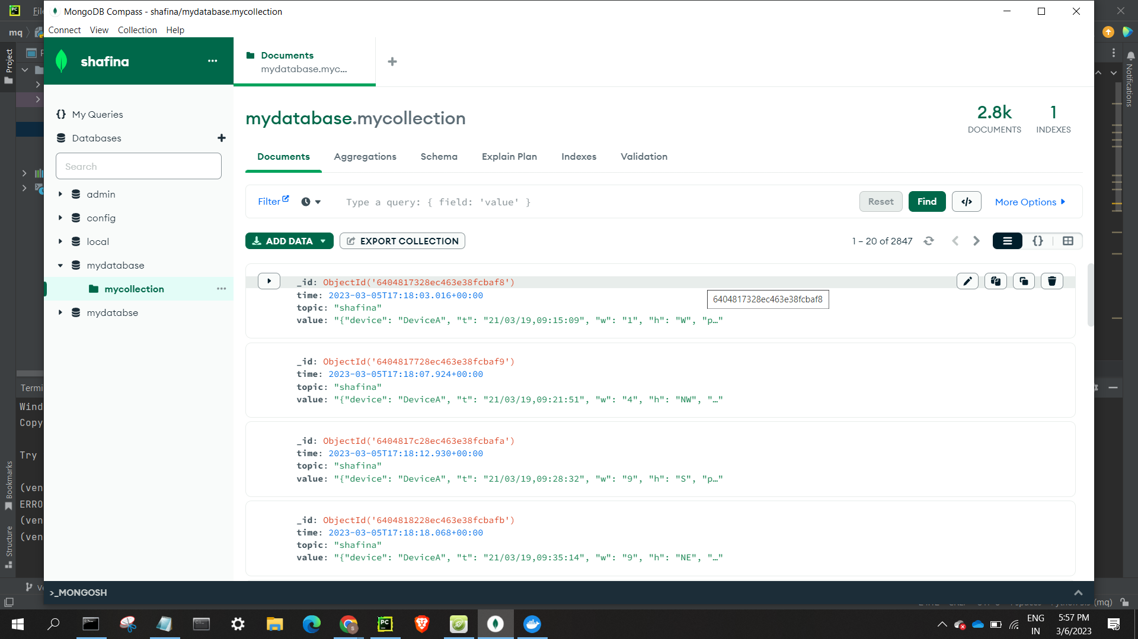
* Setting up docker image
* 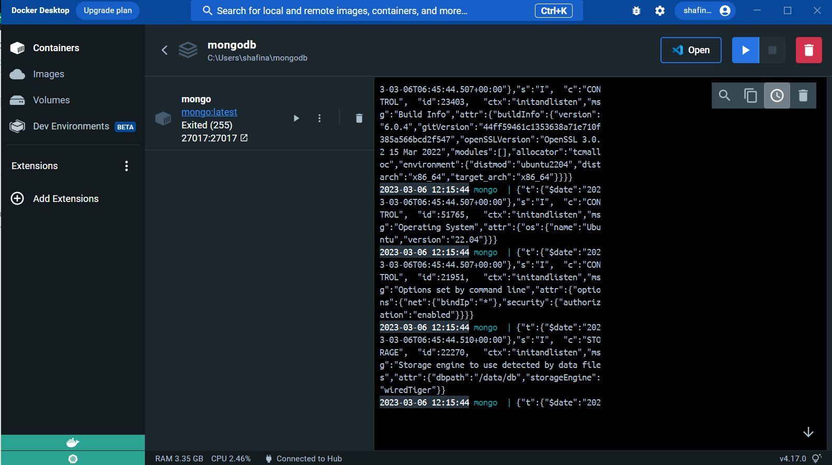
* Discrepancies while pushing to Hub
* So tried ATLAS,
* Created account and cluster
* 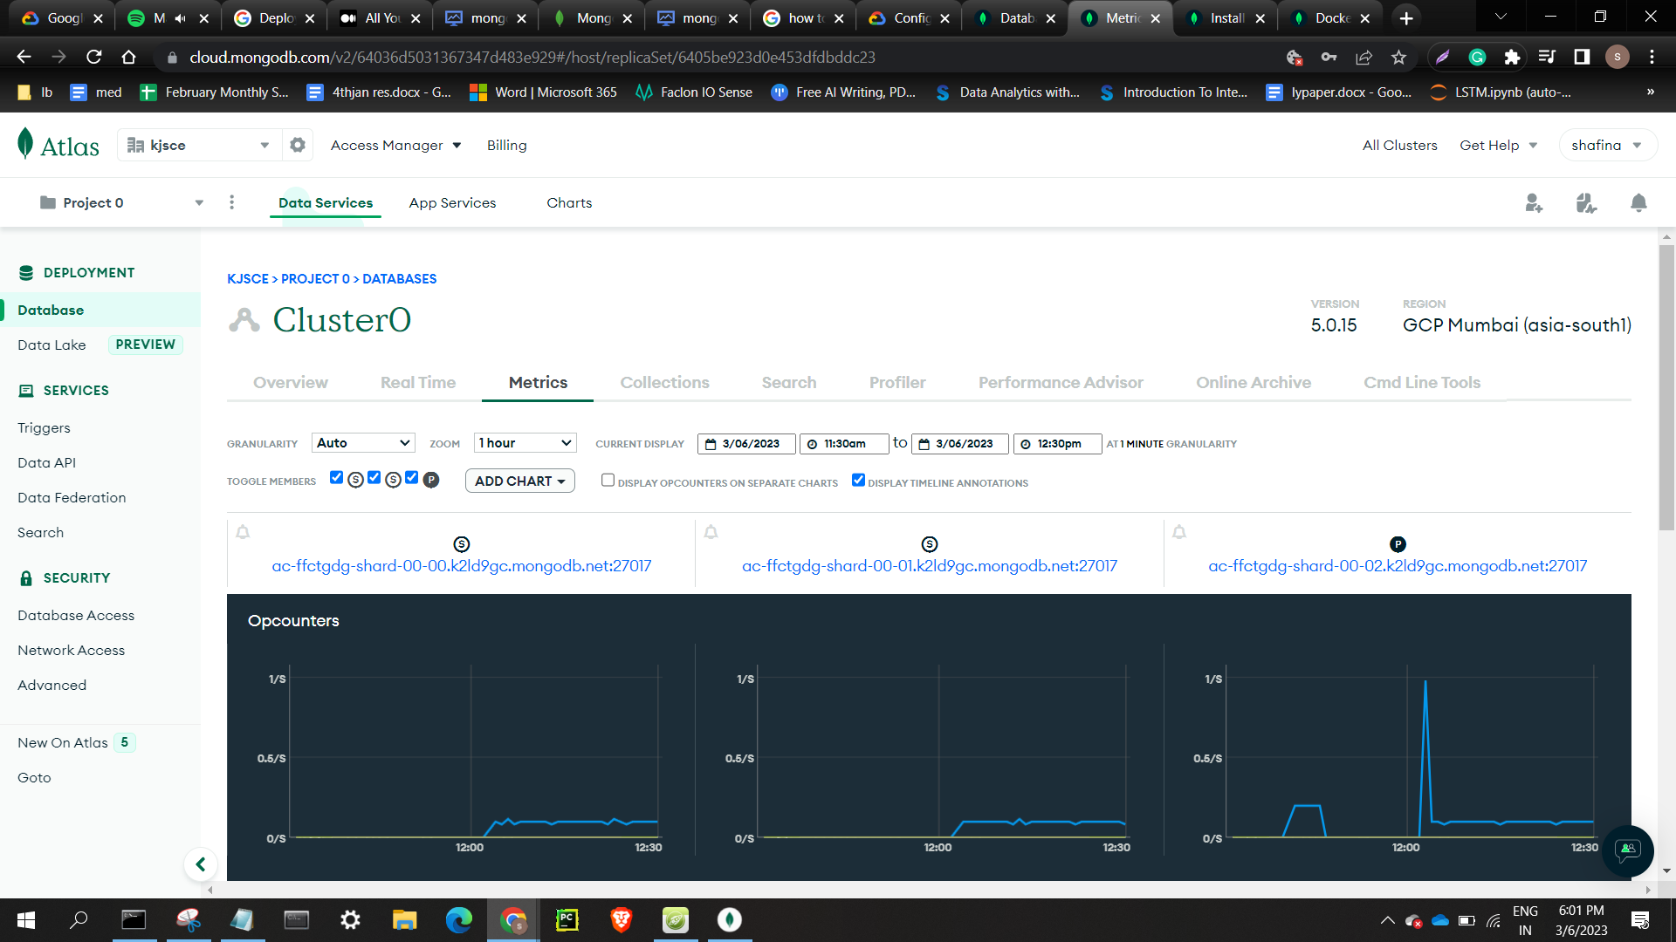
* Unable to load database from local into online cluster

Setup Google Cloud platform:

Approaches:

* Vm setup and then installing mongodb and deb dependencies:
* Faces issue with deb version
* 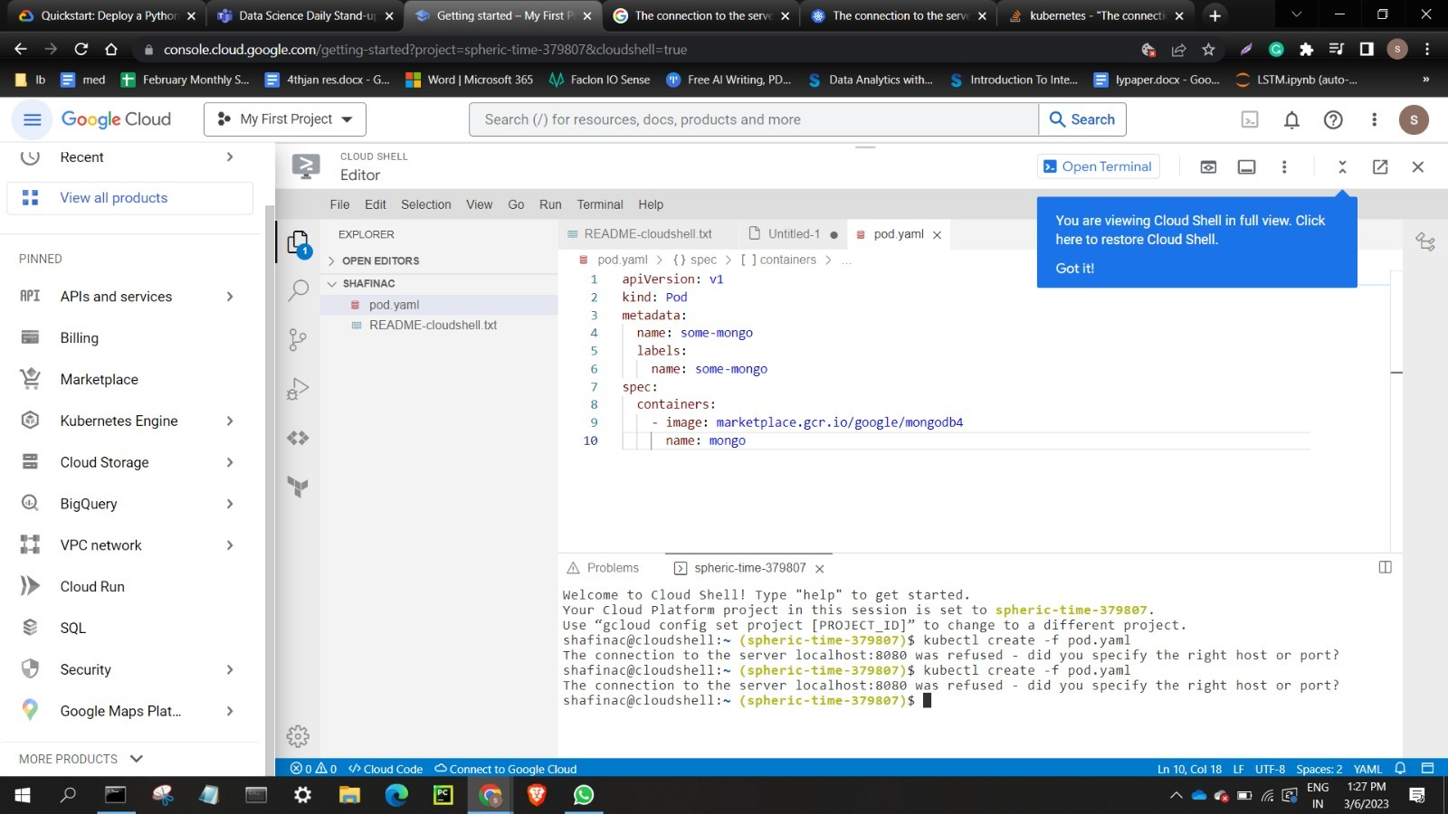
* 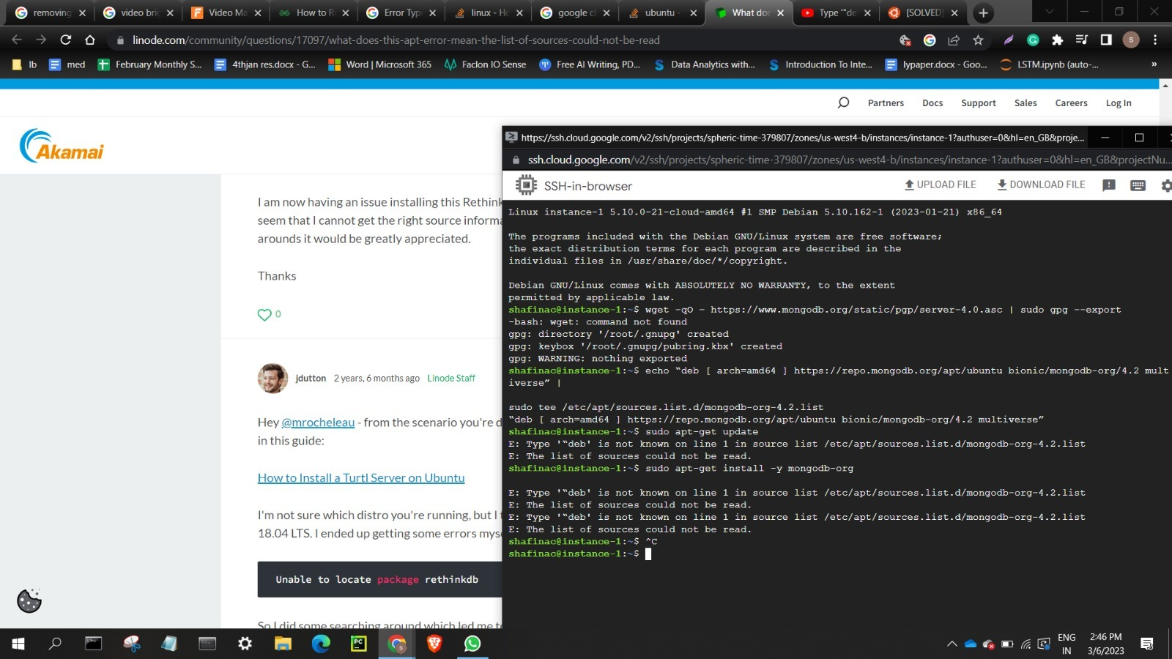

Discaded this approach

* Tried installing mongodb with GCP
* 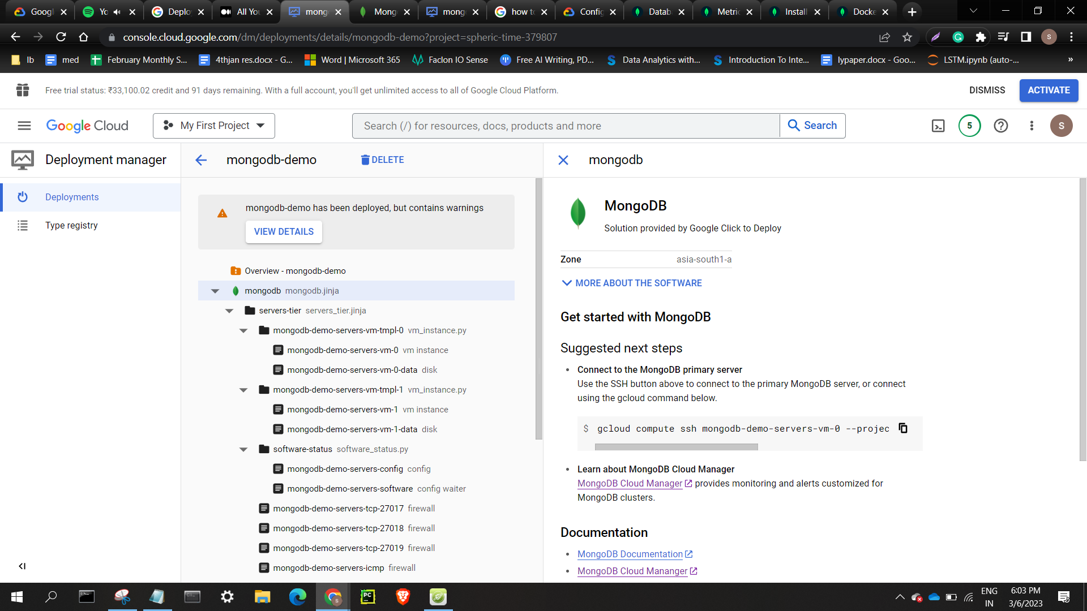
* 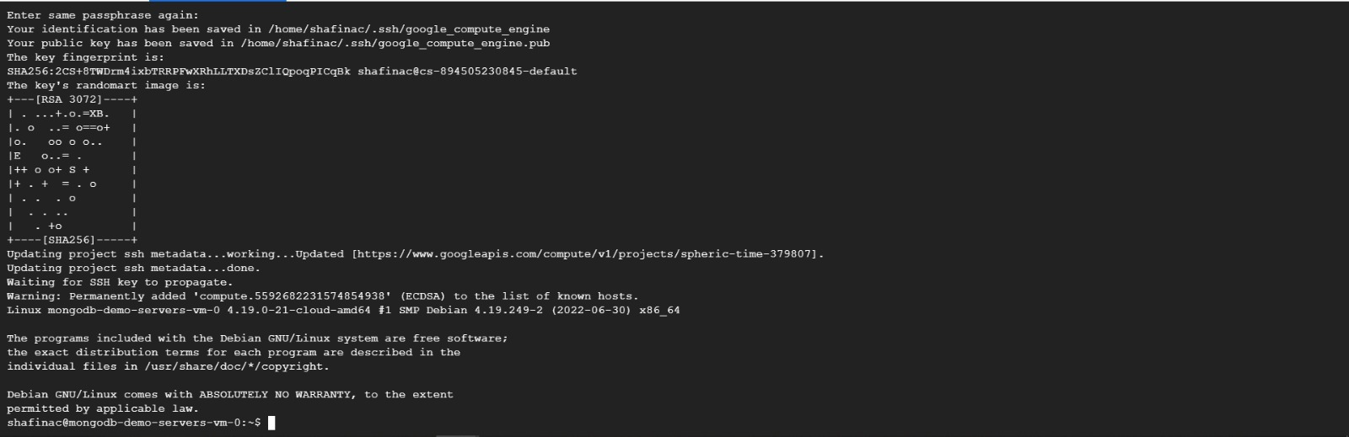
* 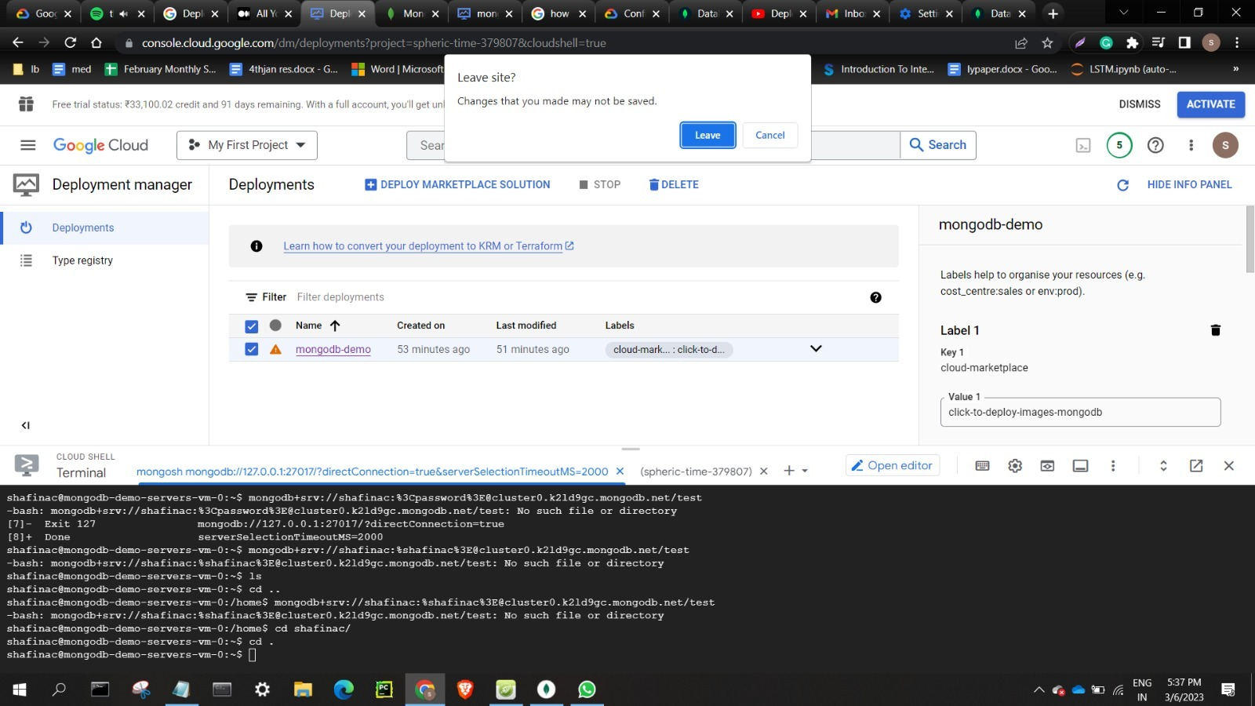
* Tried testing with nosql booster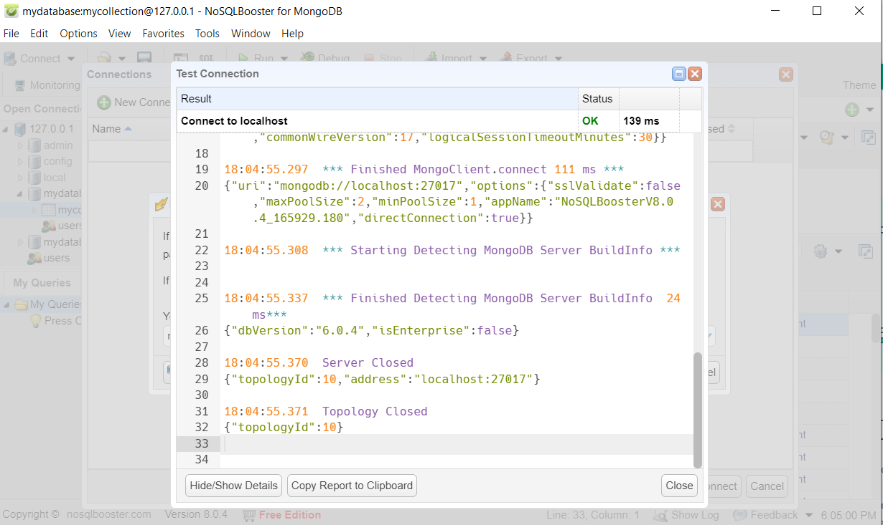
* 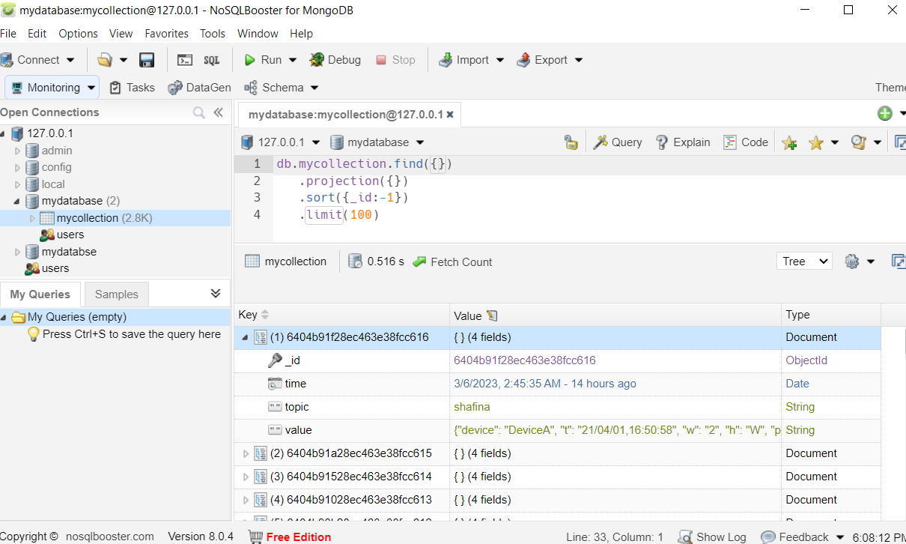
* Tried with mongosh:
* Current Mongosh Log ID: 6405c812f7c5cec9cde3aed2
* Connecting to: mongodb://127.0.0.1:27017/?directConnection=true&serverSelectionTimeoutMS=2000&appName=mongosh+1.5.4
* Using MongoDB: 5.0.11
* Using Mongosh: 1.5.4
* https://www.youtube.com/watch?v=AxrA35Itv64